Steps for zeppelin notebook-authorization.json file sync
Before going to Map the DNS to new cluster, follow the below process to copy the notebook-authorization.json file from old server (Old nonprod server)to new server (New nonprod server) and same for prod cluster.
Created a folder in s3 for taking backup of notebook-authorization.json file from old server
Below is the s3 location
s3://med-av-daas-prod-datasci-cicd/emr/zeppelin_authorization_bkp/
We need to change the permissions for a notebook before copying the the authorization.json file to s3 to verify that the changed permissions are reflected or not
Changing permissions for a notebook in old cluster
Connect to zeppelin UI and open
Below are the notebook names for prod and Non prod for changing permissions
Non prod: zeppelin_test (https://datascistg.av.ge.com/zeppelin/#/notebook/2E58TT236)
Prod: authorization_testing (https://datasciprd.av.ge.com/zeppelin/#/notebook/2KEEPWVC2)
Open the notebook and click on lock symbol on top right corner, after that change the permissions and click on save.

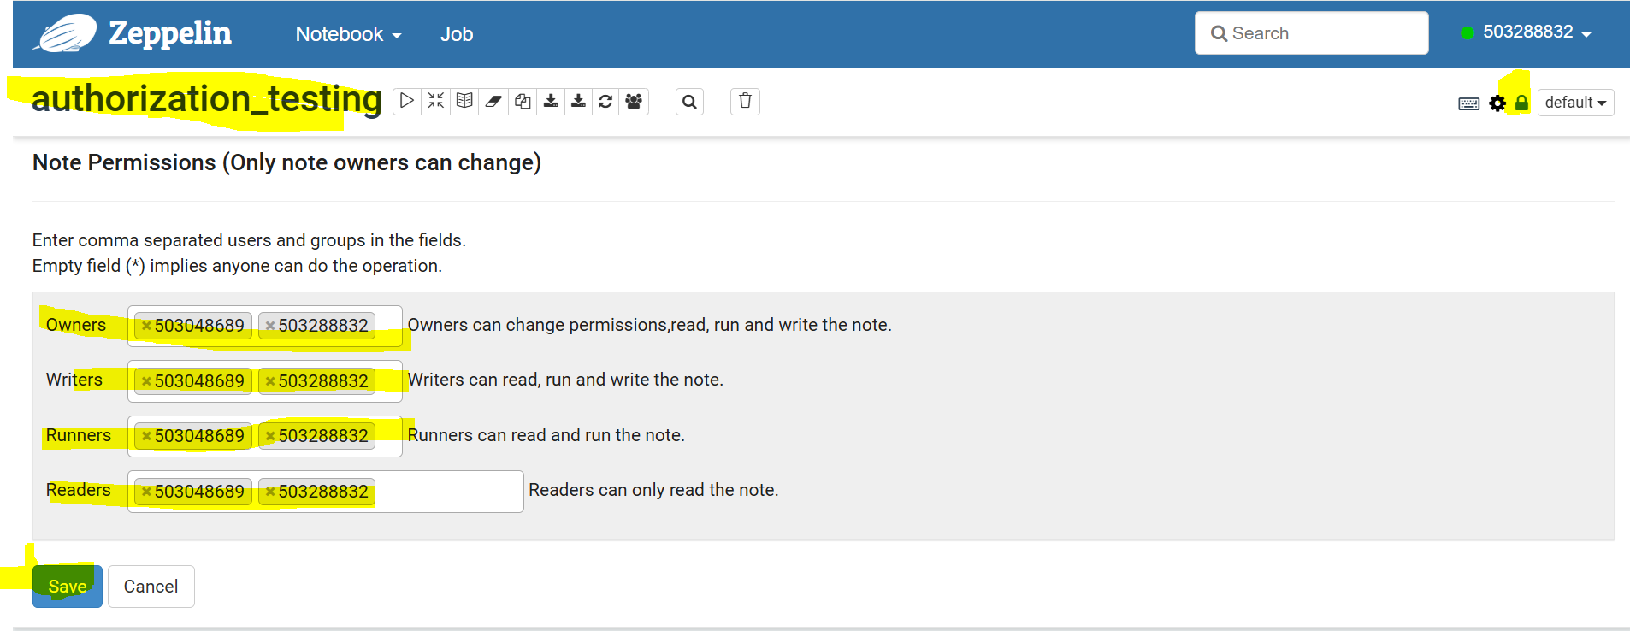

Connect to the old Ds non prod/prod cluster and perform below steps
cd /etc/zeppelin/conf
ls –ltrh
We can see notebook-authorization.json file.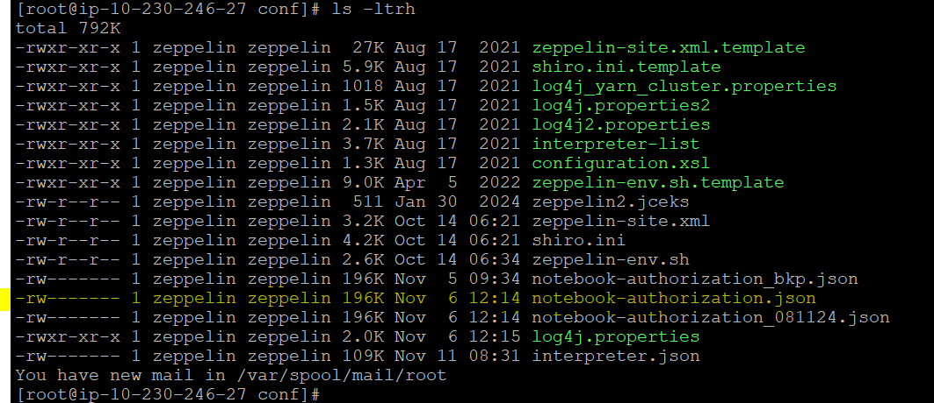
Take back of the new file with date after changing the permissions in old cluster zeppelin notebook with date.
Every time before we copy the file to s3 we need to change the name of the old file in s3 because if we upload with same name it will update the same file
Below is the command
cp -p notebook-authorization.json notebook-authorization_bkp_21022025.json
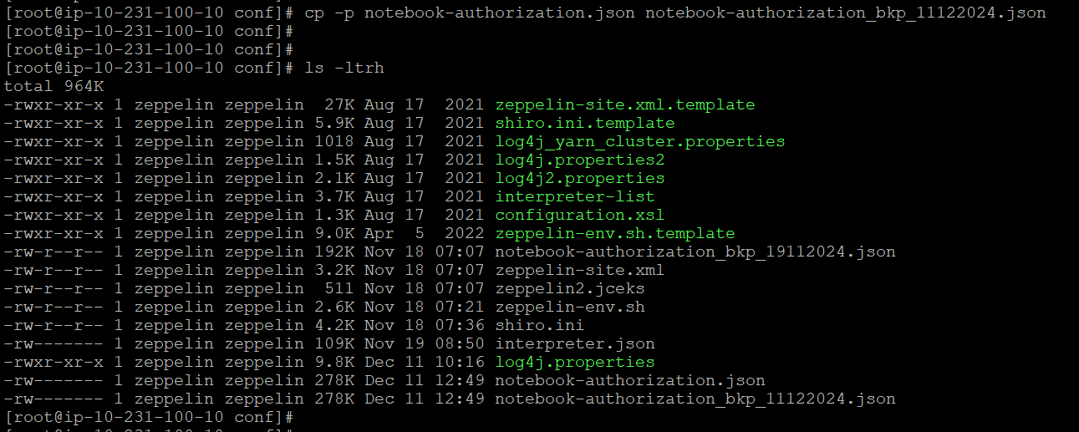
Every time before we copy the file to s3 we need to change the name of the old file in s3 because if we upload with same name it will update the same file
Copy the file to s3 location by using below command.
Non Prod:
aws s3 cp notebook-authorization_bkp_10022025.json s3://med-av-daas-preprod-datasci-cicd/emr/zeppelin_authorization_bkp/
Prod:
aws s3 cp notebook-authorization_bkp_21022025.json s3://med-av-daas-prod-datasci-cicd/emr/zeppelin_authorization_bkp/
s3://med-av-daas-prod-datasci-cicd/emr/zeppelin_authorization_bkp/notebook-authorization.json
New cluster:
Now connect to the new cluster and take the backup of notebook-authorization.json in the server
cd /etc/zeppelin/conf
ls –ltrh
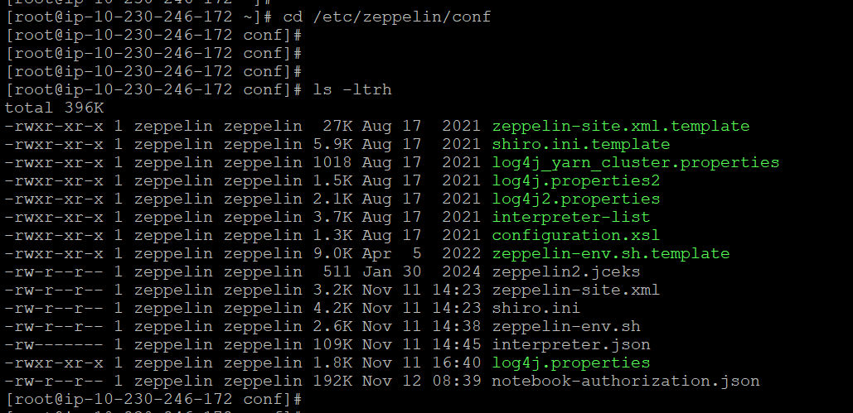
cp -p notebook-authorization.json notebook-authorization_bkp21022025.json
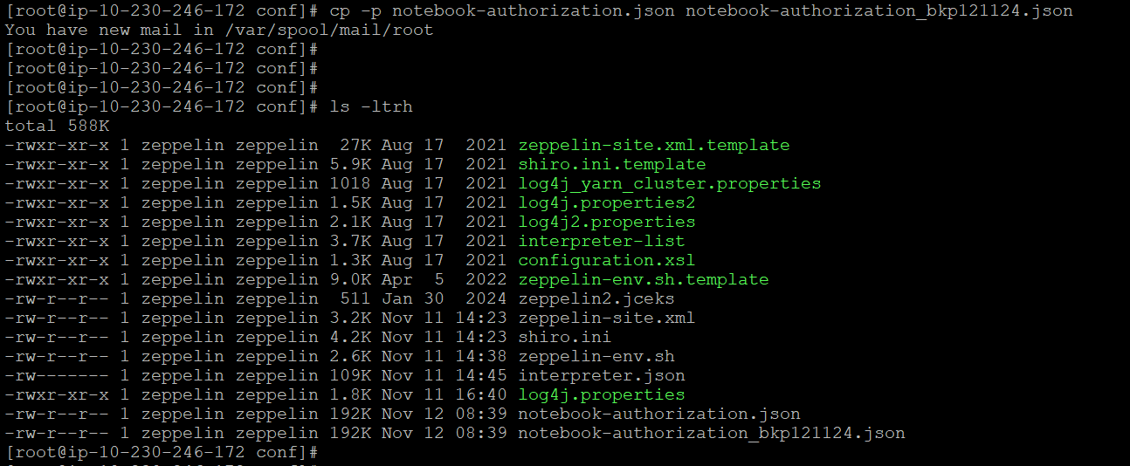
Now copy the notebook-authorization.json file from s3 to the new cluster which is uploaded to s3 from old cluster with date.
Non prod:
aws s3 cp s3://med-av-daas-preprod-datasci-cicd/emr/zeppelin_authorization_bkp/notebook-authorization_bkp_10022025.json ./notebook-authorization.json
Prod:
aws s3 cp s3://med-av-daas-prod-datasci-cicd/emr/zeppelin_authorization_bkp/notebook-authorization_bkp_21022025.json ./notebook-authorization.json
It will replace the old file. So, we need to change the ownership for the file
chown zeppelin:zeppelin notebook-authorization.json
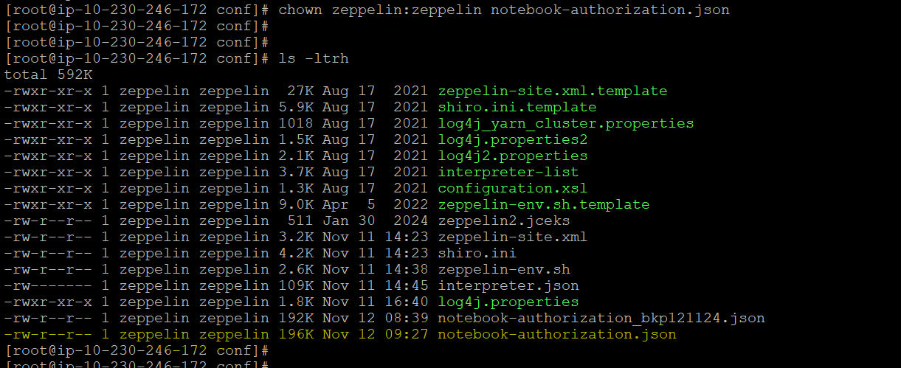
Now restart the zeppelin service and check status.
systemctl restart zeppelin.service
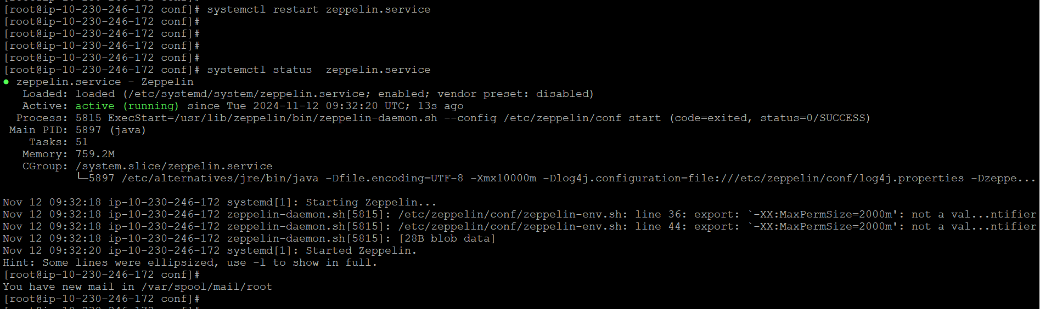
After restarting zeppelin service connect to new cluster zeppelin through tunneling and check the permissions are reflected or not by opening the notebook
Tunneling command
ssh -N -L 8890:10.231.100.19:8890 lh293126@10.231.100.19
After verifying the permissions, if everything works fine then map the ALB DNS to the new cluster.

